**SIMPLE NOTIFICATION SERVICE (SNS)**

Amazon Simple Notification Service (Amazon SNS) is a managed service that provides message delivery from publishers to subscribers Publishers. communicate asynchronously with subscribers by sending messages to a topic, which is a logical access point and communication channel.

**Create an instance:**

• Login to the AWS console

• Open Ohio region and click on instances

• Click on launch instance

• Given name tag as SNS-EC1.

• Select amazon Linux.

• Select the key pair and launch instance.

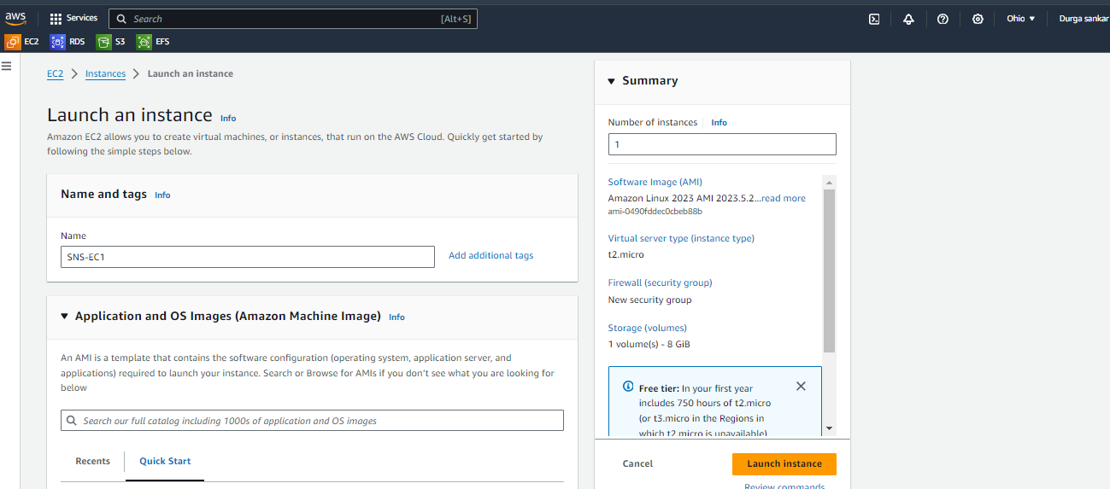

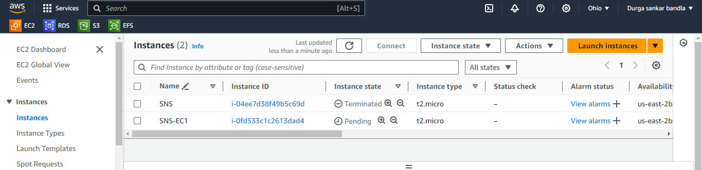

• Once instance state change to running click on connect and then you will get connection to the amazon Linux server.

• Change to root user using ----sudo -I.

• For updating the server ----yum update -y.

• For installing the stress ----yum install stress -y.

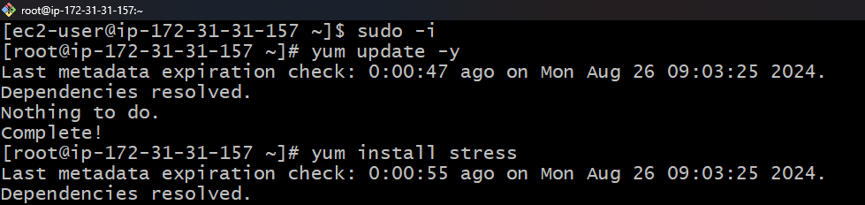

**Creating Simple Notification Service (SNS) topic:**

• Open SNS and click one create topic.

• Type should be standard.

• Give name tag as SNS.

• And then click on create topic.

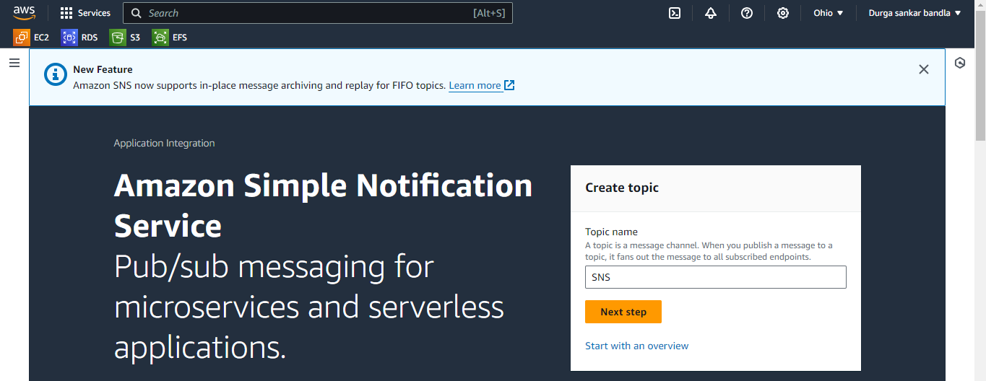

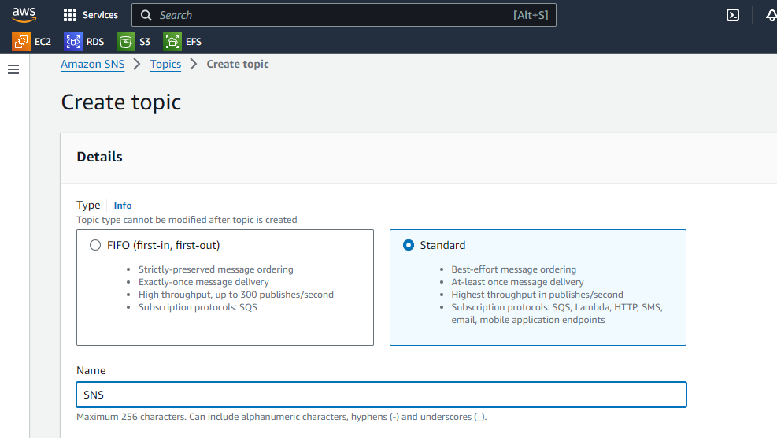

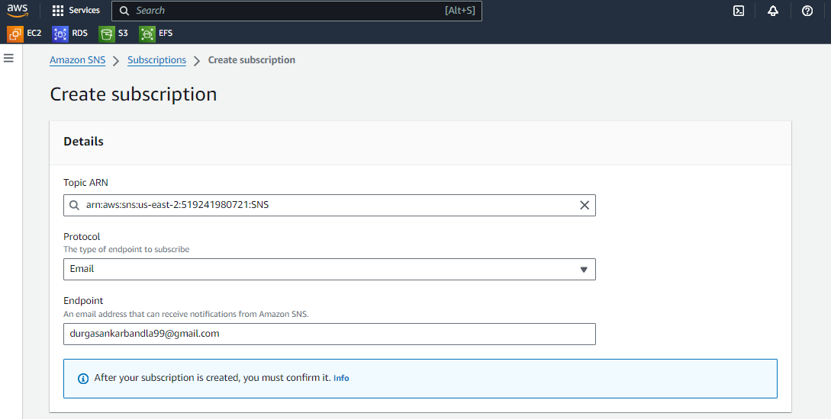

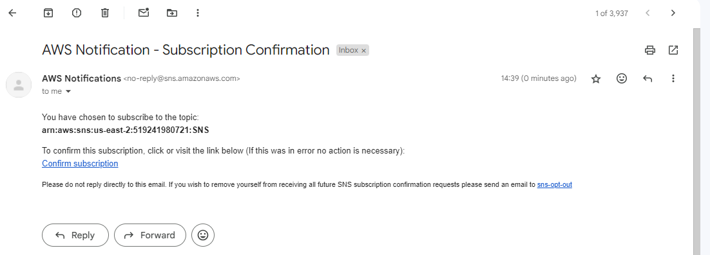

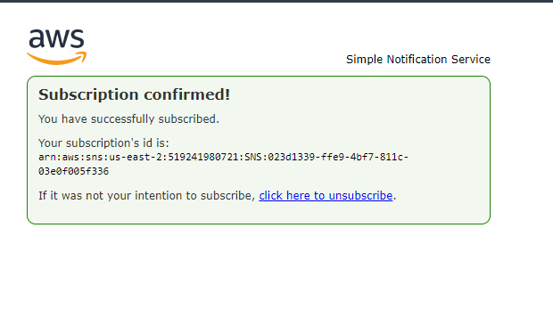

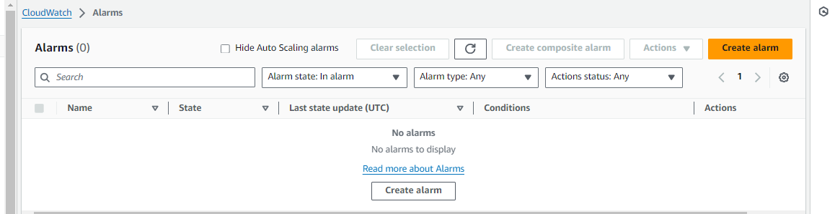

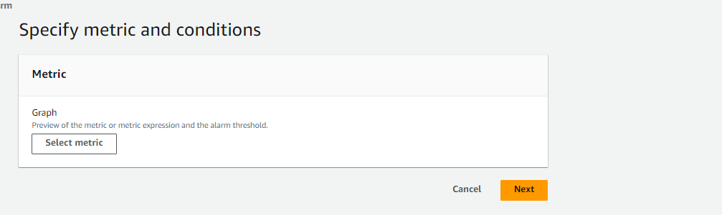

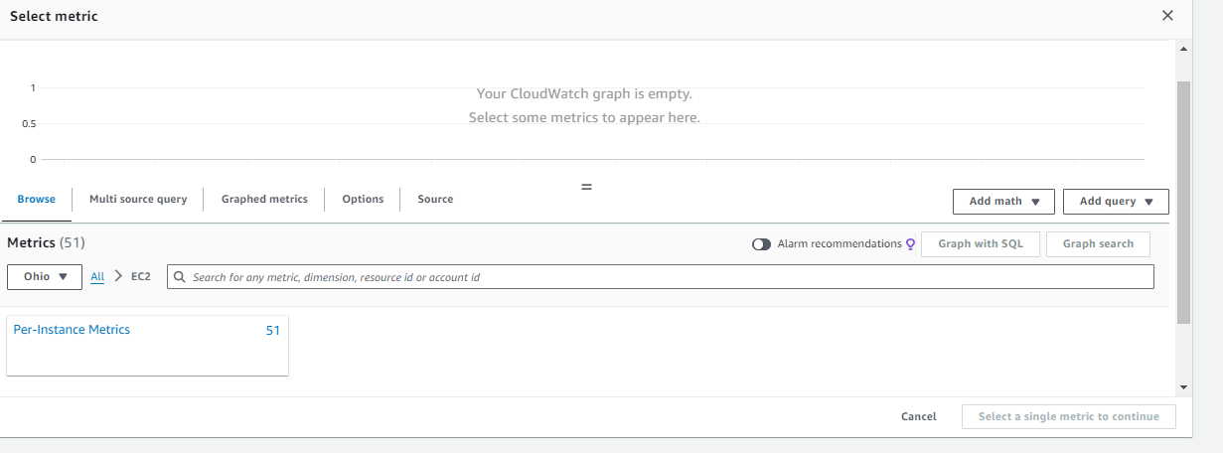

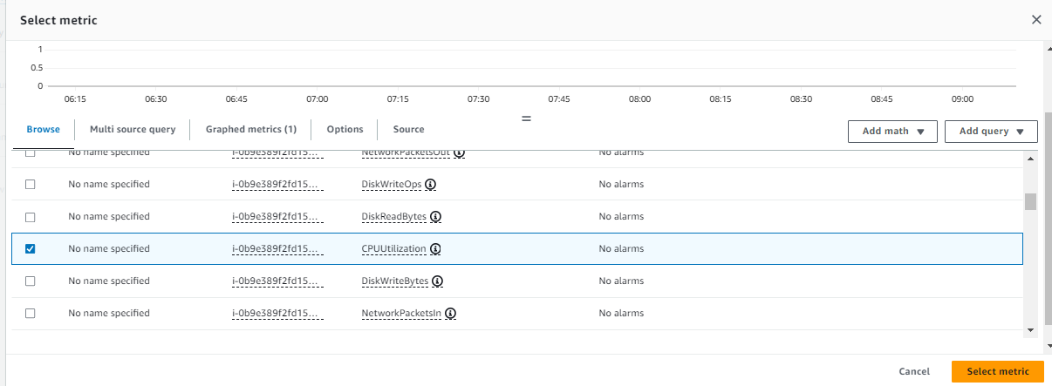

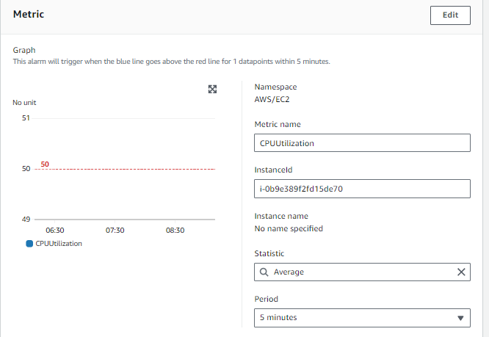

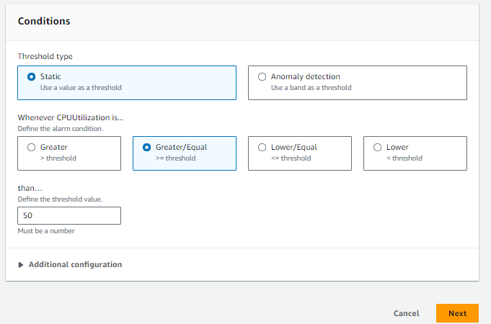

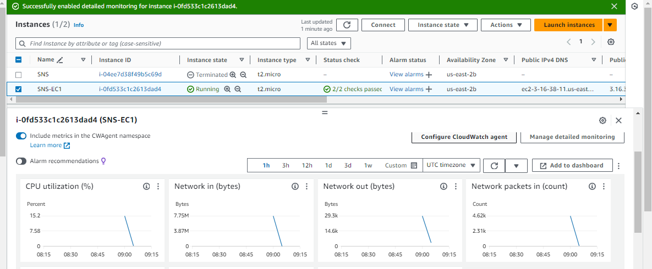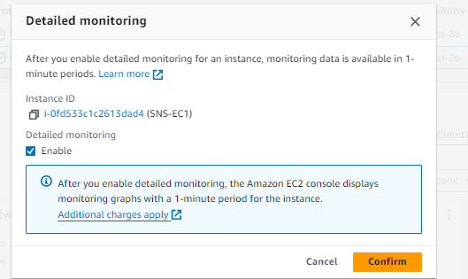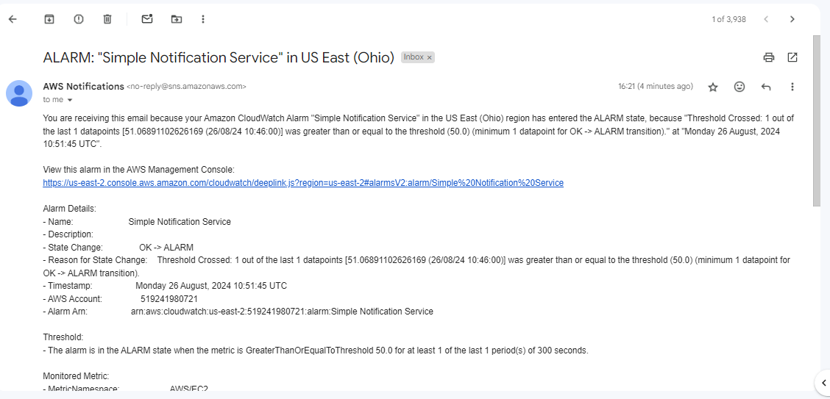

**Creating alarm in Cloud Watch :**

• Click on create alarm.

• Click on select metric.

• Click on Select per instance metrics and select the CPU utilization for instance-a and click on select metric.

• In conditions field select threshold type should be static and threshold value should be greater than or equal to 50.

• Give name tag as SNS-1 and click on create alarm as shown in below slides.

**Enable the detailed monitoring for SNS-EC1:**

• Once alarm cleared go to SNS-EC1 and click on monitoring.

• Click on managed detailed monitoring and click on enable and then hit on confirm.

• In AWS Linux server and give stress command ----stress –cpu 10 -v –timeout 400s.

• Once given stress to the instance-a the CPU utilization should be more than 50 percentage. Then we will get notification to the email.

Durgasankar Bandla

[durgasankarbandla99@gmail.com](mailto:durgasankarbandla99@gmail.com)

Batch No : **127**